Module 3- task 4
Task A: Create a procedure to fetch employees with salary > 100000 and insert them into high_salary_table
CREATE OR REPLACE PROCEDURE copy_high_salary_employees()
AS $$
DECLARE
v_count INT;
BEGIN
CREATE TABLE IF NOT EXISTS high_salary_employee
(
emp_id INT,
employee_fname TEXT,
salary INT,
dept_id INT
);
INSERT INTO high_salary_employee (emp_id, employee_fname, salary, dept_id)
SELECT employee_id, employee_fname, salary, dept_id
FROM employee
WHERE salary > 100000;
RAISE NOTICE '% employees copied', v_count;
END;
$$
LANGUAGE plpgsql;

CALL copy_high_salary_employees();
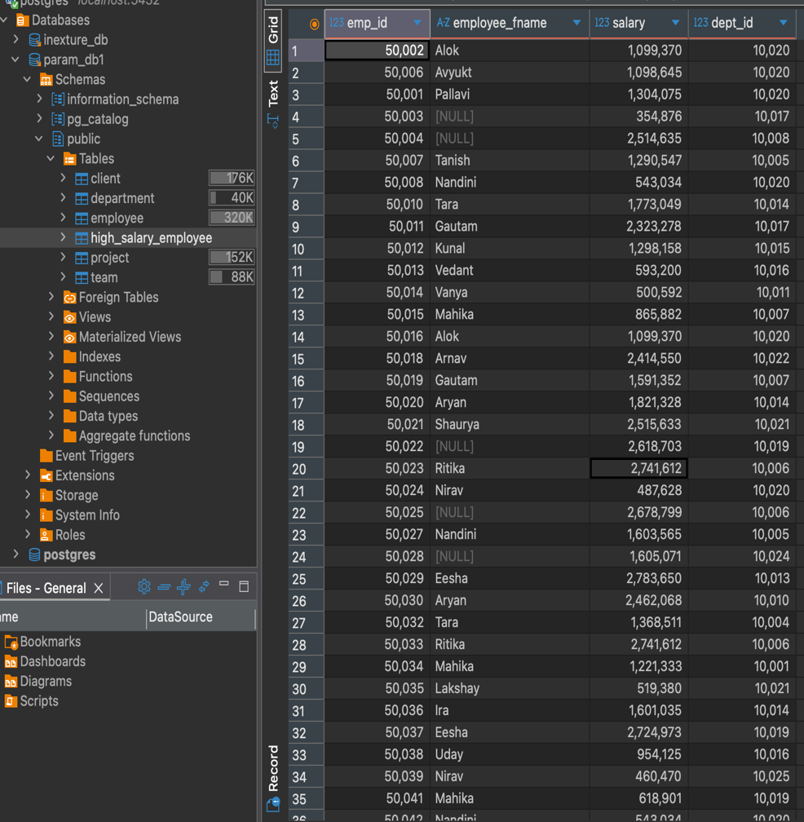
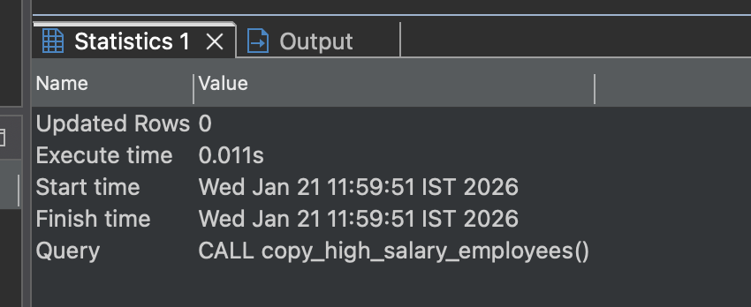

Task B: Create a view with employees whose salary is more than 100000

create or replace view high_salary_view as
select employee_fname,employee_lname,salary
from employee
where salary > 100000 and employee_fname is not null and employee_lname is not null;

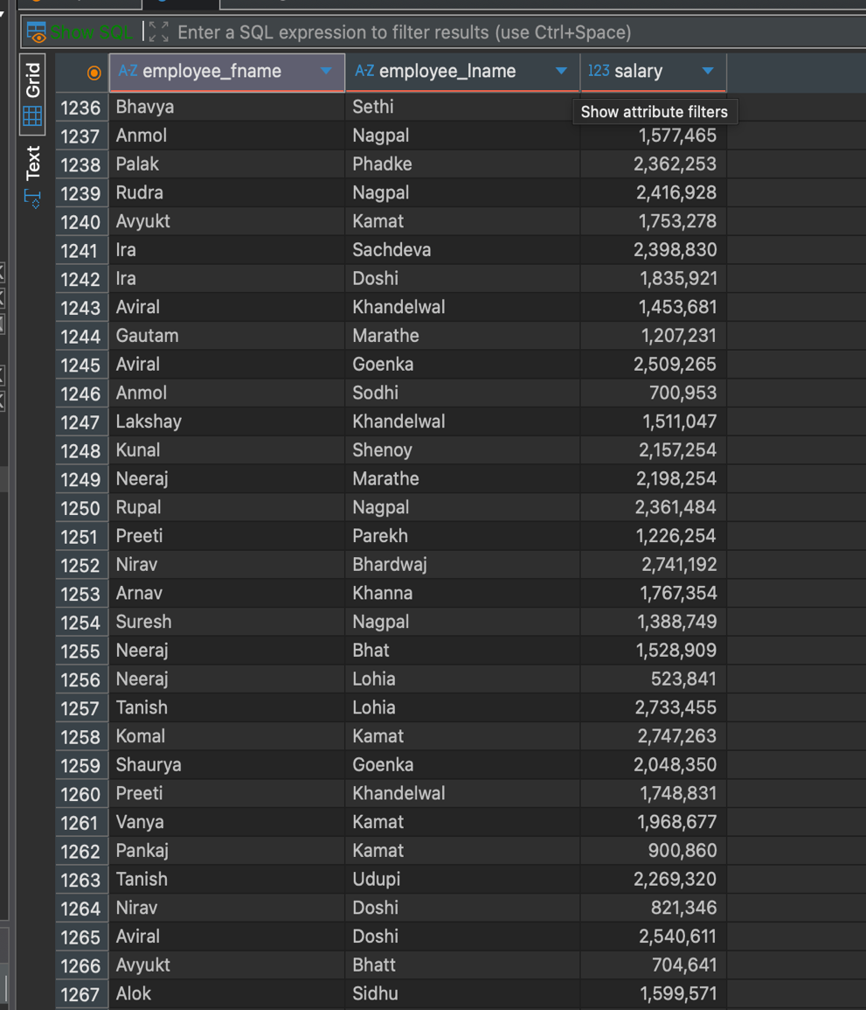
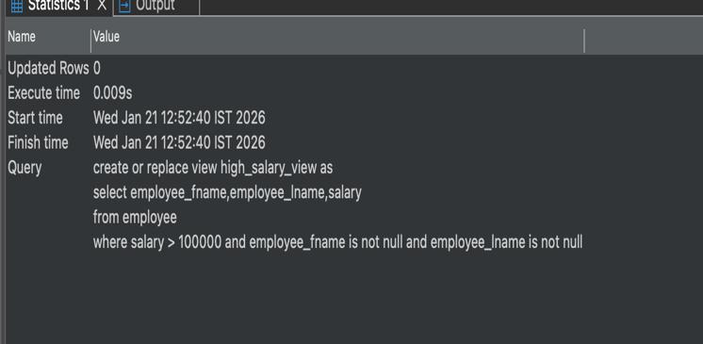

- select count(employee_fname) from high_salary_view;

